**SAMSUNG NOTE 20 PHONE REVIEWS**

As we can see, The above cloud charts . The Samsung note 20 is appreciated for its display, camera, build quality, performance, colour. I have also performed sentiment analysis on it and the major words are brilliantly ,awesome,gorgeous,significant. There were also few drawbacks that says battery drain, low latency , hefty . So by this data the manufacturer can make changes his next module to improve his sales.

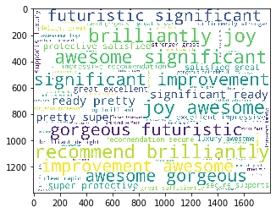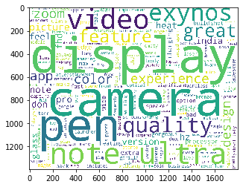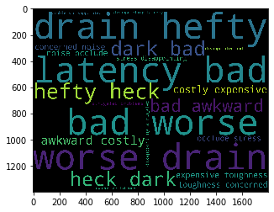

**MOVIE REVIEW : shawshank Redemption .**

**# There was some issue with my R . The images copied in R weren’t able to paste in word . So I clicked them and added it in word.**

**I have imported the reviews from IMDB movie reviews and performed some text mining then applied nltk TVIDFvectoriser to plot a word cloud. Then I have performed sentiment analysis by comparing the reviews with positive words data set and negative words data set. This is a very good movie according to the reviews , of course this one of the best rated movies in IMDB itself**

